Smart Farming System using IoT for Efficient Crop Growth

Abhiram MSD1DepartmentofECE

Chaitanya Bharathi Institute ofTechnology(A*)*

Hyderabad, India[abhirammsd@gmail.com](mailto:abhirammsd@gmail.com)

Jyothsnavi Kuppili2DepartmentofECE

Chaitanya Bharathi Institute ofTechnology(A*)*

Hyderabad, India[joshi1772000@gmail.com](mailto:joshi1772000@gmail.com)

N.Alivelu Manga3DepartmentofECE

Chaitanya Bharathi Institute ofTechnology(A*)*

Hyderabad, India[namanga04@gmail.com](mailto:namanga04@gmail.com)

***Abstract*—Smartagricultureisafarmingsystem whichusesIoTtechnology.Thisemergingsystemincreasesthequantityandqualityofagriculturalproducts.IoTdevicesprovide information about nature of farming fields and thentake action depending on the farmer input. In this paper, anIoT based advanced solution for monitoring the soil conditionsand atmosphere for efficientcrop growth is presented. Thedevelopedsystemiscapableofmonitoringtemperature,humidity,soilmoisturelevelusingNodeMCUandseveralsensors connected to it. Also, a notification in the form of SMSwillbesenttofarmer’sphoneusingWi-Fiaboutenvironmental conditionofthefield.**

**Keywords—*IoT,NodeMCU,agriculture,sensors***

1. INTRODUCTION

AgricultureistheprimaryoccupationinIndiaandisthebackbone of Indian economic system. Agriculture providesemployment opportunities to rural people on a large scale inunderdevelopedanddevelopingcountriesinadditiontoproviding food. It is the process of producing food, fiber andmany other desired products by the cultivation and raising ofdomesticanimals.Agricultureistheprimarysourceoflivelihoodforaboutmorethan58%ofIndia’spopulation.

Climatechangeswillhavesignificantimpactonagriculture by increasing water demand and limiting cropproductivityinareaswhereirrigationismostneeded.Irrigationsystem,rainfedagriculture,groundwaterirrigationare some of the methods introduced to produce healthiercrops which may not use water efficiently. In order to usewater efficiently a smart system is designed. In the systemfarmer need not make the water flow into fields manually,butthesystemautomaticallydoesthatefficiently.

Thetraditionalmethodspracticedbypeoplemayresultinhugewastageofwater.Hence,theconceptofrobotizedfarmingwithmixofIoThasbeendeveloped[1].Thetechnological advancements began to increase the efficiencyof production remarkably thus, making it a reliable system.The knowledge of properties of soil determines the watersupplytobedriveninasmartway.Thepracticeofagricultureinasmartwayhelpstoacquireknowledgeofsoilandtemperatureconditions.Developingthesmartagricultureusing IoT based systems not only increases the productionbutalsoavoidswastageofwater[2].Thesoilmoisturesensor,humidityandtemperaturesensorcontinuously

monitors thesoilandenvironmentalconditions,sends thelivedatatosmartphoneviacloud service.

While raining, the moisture content may increase severaltimes.Arain-dropdetectingsensorintimatesthecontrollerifthere is rainfall, making the water supply to reduce or stopdepending upon the moisture content at the moment. Thecrop requirements such as amount of humidity, temperatureand moisture content are to be studied and can be installedagaininthecontrollertomeetitscircumstances.

Inthispaper,thesystemusesfewsensorswhichgivestheamountofmoistureinthesoil,thehumidityandtemperature of the region, and a rain detecting sensor whichand can be used in deciding whether the crop is suitable forgrowing.AllthesesensorsalongwithNodeMCUareconnectedtotheinternetandasmartphone.

1. PROPOSEDSMARTFARMINGSYSTEM

Thesystemproposedusesamicrocontroller(NodeMCU)which has a Wi-Fi module (ESP8266) over it. Smartphonewith blynk is used as user interface. Soil moisture sensor,humidityandtemperaturesensor(DHT11)andraindetectionsensors along with DC motor and deek robot are used. ThisDC motor is connected to a water pump which pumps waterto the crops when the DC motor is ON. The soil moisturesensor senses the moisture level in the soil [3].Dependingonthelevelofmoisture,NodeMCUdecideswhethertowater the crop or not [4]. By using appropriate functions andconditional statements in the code written for the NodeMCUfunctioning, the watering of the crop starts by NodeMCUmaking DC motor ON when the moisture content is below athresholdvalueandismadeOFFwhenthereisenoughmoisture content in the soil. The humidity and temperaturesensorgives thehumidity andtemperaturevalues of theatmosphere which determine whether the crop is suitable forgrowth[5].Somecrops grow only inparticularweatherconditions and some give better yield only for a particulartemperaturerange.Theraindropsensormeasurestheintensity of rain. If there is enough rainfall to provide soilwith required water, the crops are not watered. Even afterraining, if the crops are not having sufficient water thenwaterispumpedagainbymakingDCmotorON.DatareachestheblynkcloudfromNodeMCUthroughWi-FifromWi-Fi module present on NodeMCU [6]. The data then goestoblynkappinsmartphonewheretheusercanseethehumidity,temperature,soilmoisturelevelsandgetthenotificationsifthereisrainfallandiftheDCmotorisON.

2020IEEEInternationalStudents'ConferenceonElectrical,ElectronicsandComputerScience(SCEECS)978-1-7281-4862-5/20/$31.00©2020IEEE10.1109/SCEECS48394.2020.147

From this app, the farmer can control the DC motor throughvarious buttons and switches. When the NodeMCU gets thecommand from the app then the appropriate analysis is doneandtheDCmotoriscontrolled.Thedataagaintravelsthrough Wi-Fi again in the same path. The flow of the SmartfarmingsystemisasshownintheFig.1.

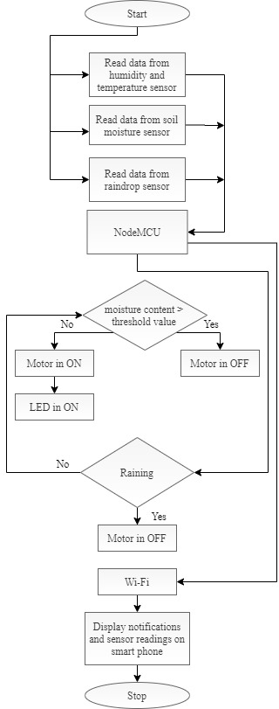

Fig.1. FlowoftheSmartFarmingsystem.

1. IMPLEMENTATIONOFSMARTFARMINGSYSTEM

The block diagram of proposed Smart Farming systemusingIoTisshowninFig.2:

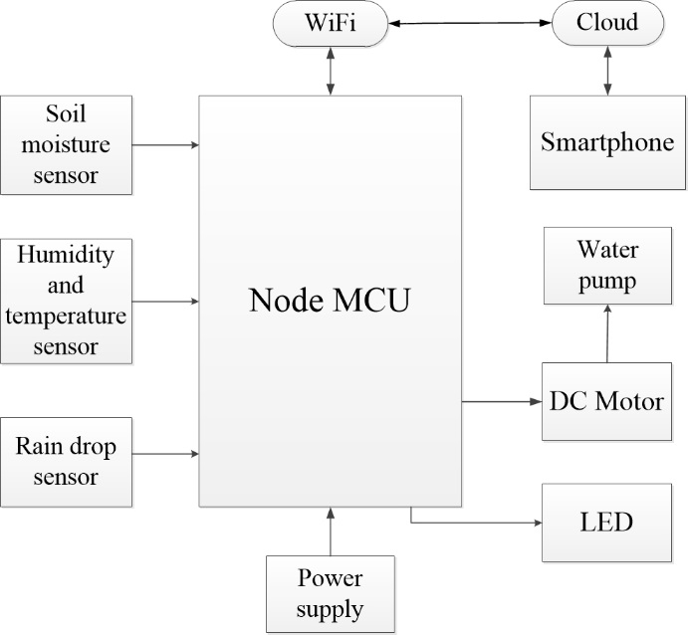

Fig.2.BlockdiagramoftheSmartFarmingsystem.

Humidityandtemperaturesensor(DHT11)showninFig. 3, consists of a thermistor, humidity sensing componentandanIC.Thermistorcalculatesthetemperatureofitssurroundingmediumfromitscapabilityofvaryingitsresistance due to temperature. A moisture holding substrateisplacedbetweentwoelectrodesinhumiditysensingcomponent. Thevariation inhumidity produces avariationin resistance between electrodes. The variation in resistanceismeasuredandprocessedbytheICwhichgivesthehumidity value to the NodeMCU. This sensor operates at avoltage range of 3.3V to 5V. The range of temperature is 0 -50°C, range of humidityis20 -90%RH.

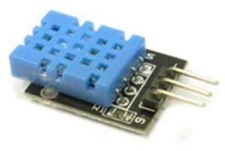

Fig.3.Humidityandtemperaturesensor.

The Soil Moisture Sensor in Fig. 4 calculates the averageofdielectricpermittivityalongthelengthofthesensor.Here,dielectricpermittivityisfunctionofwater.Thetemperaturerangefortheworking of this sensoris 10-30°Candvoltage applied is5V.

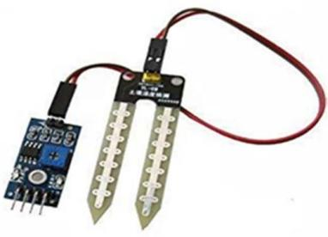

Fig.4.Soilmoisturesensor.

SCEECS2020

In raindrop sensor shown in Fig. 5 as raindrops fall onthenickellinesthedropconnectstheselinesin parallelwhich reduces the resistanceand hence the voltage dropacross the lines is also reduced. This happens because wateris a good conductor of electricity. So when the voltage dropis less than a certain value it indicates that it’s raining. Themodule has a rain board, a control board, power indicatorLED, and an adjustable sensitivity through a potentiometer.Its operating voltage is 5V. The range of resistance is from100KOhmto2MOhm.

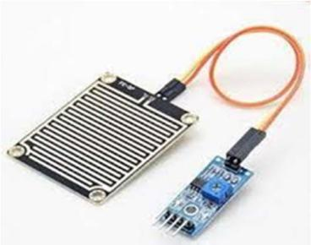

Fig.5.RaindropSensor.

DC Motor in Fig. 6 converts DC electrical power intomechanicalpower.ItworksontheprincipleofLorentzLaw.TheDCmotorcanmoveinbothclockwiseandanticlockwise directions depending on the sign of voltageapplied between its terminals. The DC motor operates at arangeof3to 9Vand runsata speed of3000RPM.

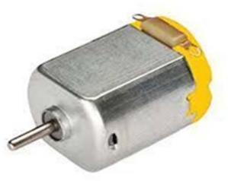

Fig.6.DCmotor.

NodeMCUinFig.7isanopen sourceIoTplatformwhichincludesfirmwarethatrunsonESP8266Wi-Fimodule. Programming is done in Arduino IDE using C/C++language or Lua script. NodeMCU has 16 GPIO pins whichcan be used to control other peripheral devices like sensors,LEDs, switches etc. These pins can also be used as PWMpins. It has two UART interfaces and uses XTOS operatingsystem [7]. It can store 4M Bytes of data. The operatingvoltage of NodeMCU is 5V. It uses L106 32-bit processor,and the processor'sspeed is80-160MHz.

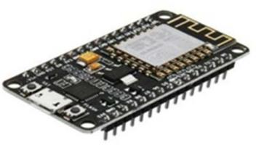

Fig.7.NodeMCU.

Deek Robot in Fig. 8 acts as an interface to the outputdevice DC motor. It is a current amplifier and so providesenough current to drive the DC motor [8]. Deek Robot hasover temperature protection and it has internal clamp diodes.Ithashighnoise immunity.

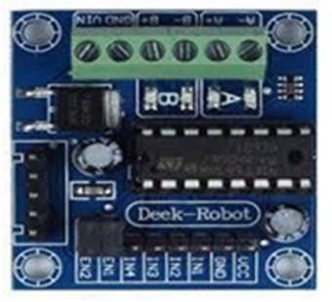

Fig.8.Deek Robot.

Blynkisanopen-sourceplatformdesignedforIoTwhich can control hardware remotely, can display sensordata, can store data, visualize it. The components of thisplatform are a server which can be ran privately or use thecommonone,anappandlibraries.Everytimesomeinformation is given from the blynk app, the informationtravelstotheblynkCloud,fromthereitautomaticallyfindits way to the hardware. The connection between the cloudandtheappcanbethroughWi-Fi,Bluetooth,GSM,Ethernet etc. The state of hardware pins can be manipulatedby the commands given in the blynk app through variouskinds of widgets present. Authentication token is generatedafter every project is created and it is a unique identifierwhichconnectsthe hardwareandthe smartphone.

ThedatafromHumidityandtemperaturesensor,raindrop sensor is sent to the digital pins of the NodeMCU.The data from Soil moisture sensor is sent to the analog pinof the NodeMCU. DC motor is connected to the NodeMCUvia deek robot which is connected to two digital pins ofNodeMCU.Serialmonitordisplaysthedatagivenbysensors if serialfunctions arewritten in the code andifserialcommunicationbetweentheNodeMCUandthedevice exists. Name of the Wi-Fi network and password arewritten along with the Authentication token in the code toconnectthehardwaretoblynkapp.Whenthecodeisdumped into the hardware, from then the status of the cropsandsoilalongwiththeDCmotorstatusisseenonsmartphonewhenconnectedtoWi-Fi.Thenotificationsreceived and the values of humidity, temperature and soilmoistureinblynkfortheSmartFarmingsystemareasshowninthebelowfiguresFig.9,Fig.10,Fig.11andFig.

12. The model for the Smart Farming system is as shown inthe figureFig.13.

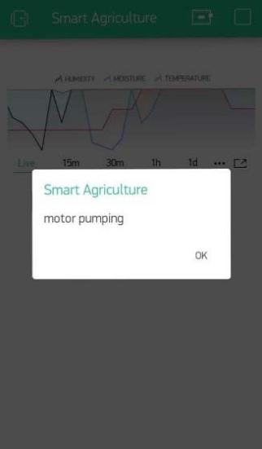

Fig. 9. Notification in blynk when the DC motor is pumping water tothecropsatthefarm.

SCEECS2020

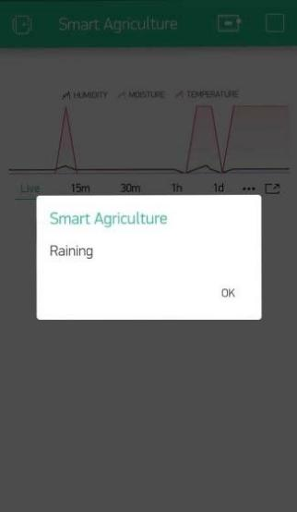

Fig.10.Notificationinblynk when thereisrainfallatfarm.

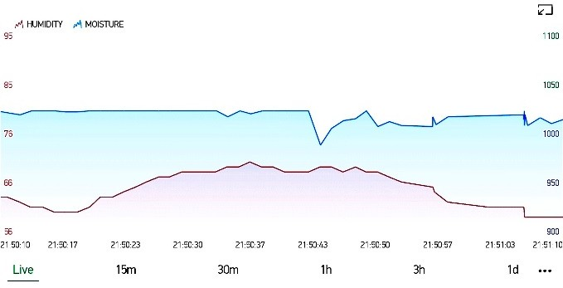

Fig.11.Graphinblynkshowingthevaluesofhumidityandmoisturecontentinthesoilof thefarm.

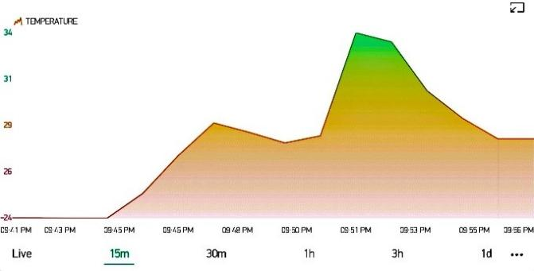

Fig.12.Graphinblynk showingthevaluesoftemperatureofthefarm.

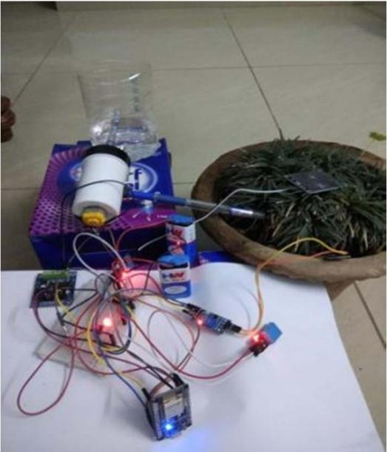

Fig.13.ModeloftheSmartFarmingsystem.

1. CONCLUSION

Inthispaper,IoTtechnologyisusedtosenseandanalyze the temperature, humidity level, soil moisture leveland the rain condition and DC motor is controlled usingNodeMCU. All these values are sent to the smart phoneusing Wi-Fi. Due to the usage of this system, adequate wateris pumped and rain is also utilized efficiently. This system isvery much helpful to farmers as they need to regularly pumpwater and check the status of each crop. From anywhere intheworld,farmerscanknowthevaluesofhumidity,temperature and soil moisture and if the DC motor is ONthroughtheblynkapppresentintheirsmartphones.

REFERENCES

1. Pradyumna Gokhale, Omkar Bhat, Sagar Bhat,"Introduction to IOT",International Advanced Research Journal in Science, Engineering andTechnology(IARJSET), Vol.5, Issue1,January2018.
2. Brian Gilmore,"The Next Step in Internet Evolution: The Internet ofThings", Internet ofThings,cmswire, Jan2014.
3. A.Anusha, A.Guptha, G.Sivanageswar Rao, Ravi Kumar Tenali, “AModel for Smart Agriculture Using IOT”, International Journal ofInnovative Technology andExploring Engineering (IJITEE),ISSN:2278-3075,Volume-8Issue-6, April2019.
4. Muthunoori Naresh, P Munaswamy,” Smart Agriculture System usingIoT Technology”,International Journal of Recent Technology andEngineering (IJRTE), ISSN: 2277-3878, Volume-7 Issue-5, January2019.
5. Nikesh Gondchawar, Prof. Dr. R. S. Kawitkar, ”IOTbased smartagriculture”,InternationalJournalofAdvancedResearchinComputerandCommunicationEngineering,Vol. 5, Issue 6,June2016.
6. Anand Nayyar, Er. Vikram Puri,” Smart Farming: IoT Based SmartSensorsAgricultureStickforLiveTemperatureandMoistureMonitoring using Arduino, Cloud Computing & Solar Technology”,November2016.
7. [www.wikipedia.org](http://www.wikipedia.org/)
8. Sweksha Goyal,Unnathi Mundra,Prof. Sahana Shetty,” SMARTAGRICULTURE USING IOT”, International Journal of ComputerScience andMobileComputing,Vol.8Issue.5,pg. 143-148, May2019.

SCEECS2020